**S.4600**

**• Newly Carpeted & Decorated Throughout**

**• Walking Distance of the Town Centre**

**• Private Off Road Parking Space**

**A Well Laid Out & Spacious, Newly Completed 2-Bedroomed Ground Floor Apartment with Parking Space to Rear**

**Offers in the Region Of: £145,000**

**• UPVC Sealed Unit Double Glazing**

**• Gas Fired Central Heating**

**• Newly Fitted Kitchen & Bathroom**

GATEHOUSE APARTMENTS

49A HIGH STREET, NORTHALLERTON

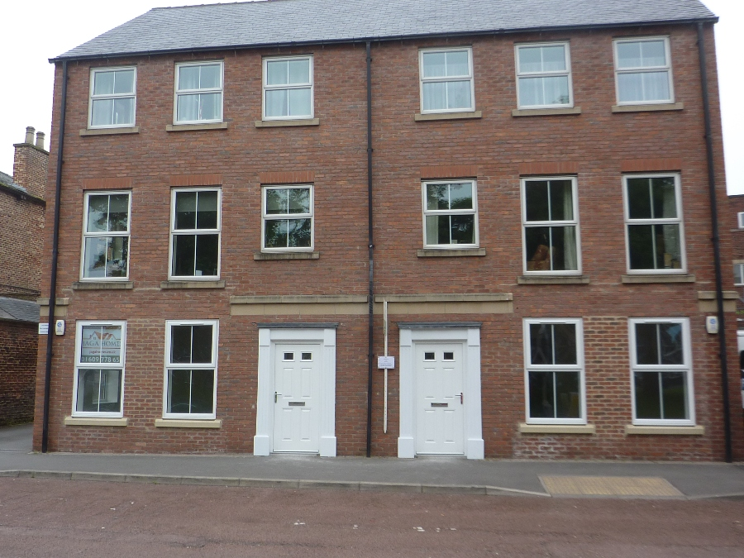

**Gatehouse Apartments, 49A High Street, Northallerton**

**SITUATION**

## Darlington 16 miles Bedale 9 miles

A.1 8 miles Thirsk 7 ½ miles

A.19 7 miles Teesside 16 miles

York 30 miles

(All distances are approximate)

**The Gatehouse** is situated directly off the High Street opposite the Church close to the centre of the very popular and much sought after market town of Northallerton the County Town of North Yorkshire. From the front this apartment is on the right.

The property lies within convenient and easy commuting distance of Bedale, the A.1, A.19 trunk roads, Teesside, York, Darlington, Thirsk and all surrounding towns and villages.

The town of Northallerton enjoys a full and comprehensive range of educational, recreational and medical facilities and additionally the property is within easy travelling distance of the local village of Brompton which enjoys a further good range of local amenities.

This area of North Yorkshire is ideally placed for commuting with an East Coast main line train station at Northallerton linking London to Edinburgh and bringing London within 2 ½ hours commuting time. Additionally via the Transpennine route that calls at this station there is direct access to Newcastle, Middlesbrough, Darlington, Leeds, York, Manchester, Liverpool and Manchester Airport.

The A.1 and A.19 trunk roads are both within easy reach of the property and offer excellent communications and access onto the main arterial road networks of the UK.

International Airports can be found at Durham Tees Valley (30 minutes), Leeds/Bradford,Newcastle and Manchester.

This area of North Yorkshire lies between the North Yorkshire Dales and the North Yorkshire Moors National Park where much renowned walking, riding and leisure activities can be found. Additionally the property is within an hour of the Coast at Scarborough, Whitby and Redcar which offers further opportunities of varied and interesting leisure activities. In and around the town of Northallerton there is additionally good walking, fishing and riding to be enjoyed.

# AMENITIES

**Shopping** – market town shopping is available at Northallerton, Bedale, Thirsk, Darlington andRichmond. The major centres of Teesside, Leeds, Durham and York are all readily accessible.

**Hospitals –** the Friarage Hospital is located very close to this property.

**Bus Service** – there is a regular bus service to Darlington calling at the villages.

**Schools** – the area is well served by good state and independent schools. Comprehensive schools at Northallerton, Thirsk, Bedale, Richmond and Darlington. Independent Schools at Polam Hall (Darlington), Hurworth House, Teesside High, Yarm, Ampleforth, Queen Mary’s at Baldersby and Cundall Manor.

**Shooting & Fishing** – the property is attractively positioned in an area renowned for its quality shoots and good fishing being within easy reach of the North Yorkshire Moors and North Yorkshire Dales and close to local rivers and ponds.

**Racing** – Catterick, Ripon, Thirsk, York, Sedgefield, Beverley, Doncaster and Newcastle.

**Golf** – Romanby (Northallerton), Bedale, Thirsk, Darlington, Richmond and Catterick.

**Walking & Cycling** – the area is well served for attractive cycling and walking with some particularly attractive countryside and scenery around the property.

**Leisure Centres –** Northallerton, Bedale, Richmond and Darlington

**DESCRIPTION**

The property comprises a ground floor two bedroomed apartment within walking distance of all local amenities and overlooking the Church. The property comes with a parking space, UPVC sealed unit double glazing and gas central heating.

**ACCOMMODATION**

In through composite front door with upper clear glass panels and a moulded surround into:

**Open Plan Living Area**

**6.25m x 6.62m (20’6” x 21’9”) max overall**

Nicely delineated into sitting, dining and kitchen areas with the sitting and dining areas having two double radiators, two ceiling light points, TV and telephone points, Sky point and twin windows to front providing for a nice degree of natural light. Kitchen area enjoys the benefit of newly fitted quality kitchen comprising range of white base and wall cupboards with granite effect work surfaces, inset 1 ½ bowl single drainer stainless steel sink unit. Unit inset four ring brushed steel Lamona gas hob with Lamona fan assisted oven and grill beneath. Space and plumbing for washer and dishwasher. Space for fridge freezer. Ceiling inset spots. Brushed steel extractor over hob. From the rear of the kitchen is:

**Entrance Hall**

**8.99m x 1.42m (29’6” x 4’8”) max overall**

With three ceiling light points. Double radiator.

**Useful Built in Store / Office**

**2.10m x 1.08m (6’11” x 3’7”)**

With telephone point. Ceiling light point. Power points. Radiator.

**Bedroom No. 1**

**2.64m x 4.93m (8’8” x 16’2”)**

With picture window to side. Two ceiling light points. Double radiator. Telephone points. TV point.

**Bedroom No. 2**

**3.40m x 2.66m (11’2” x 8’9”)**

Two ceiling light points. Double radiator. TV point. Built in boiler cupboard housing Baxi Duotech combination gas fired central heating boiler. Picture window to side.

**Bathroom**

**1.85m x 2.10m (6’1” x 6’11”)**

Newly fitted quality white suite comprising panelled bath with a hinged bar shower screen. Mains bar shower. Matching duoflush WC and pedestal wash basin. Tiled splashback to washbasin. Fully tiled around bath area. Inset ceiling light spots. Inset Advent extractor fan. Radiator.

**GENERAL REMARKS & STIPULATIONS**

**VIEWING**

By appointment through Northallerton Estate Agency – Tel: (01609) 771959

**SERVICES**

Mains Gas, Electricity & Water.

**MANAGEMENT CHARGE**

£782.01 per annum.

**TENURE**

Leasehold.

**LOCAL AUTHORITY**

Hambleton District Council, Civic Centre, Stone Cross, Northallerton, North Yorkshire – Tel: (01609) 779977.

**COUNCIL TAX**

We are verbally informed by Hambleton District Council that the council tax band is **B.** The annual charge is **£1186.39.**

